***­­­­­­­­***

***Index***

User Guide

1. ***Introduction***
2. ***Objectives***
3. ***Problem Statement***
4. ***Hardware/ Software Requirements***

***Introduction***

***The thirst for learning, upgrading technical skills and applying the concepts in real life environment at a fast pace is what the industry demands from IT professionals today. However busy work schedules, far-flung locations, unavailability of convenient time-slots pose as major barriers when it comes to applying the concepts into realism. And hence the need to look out for alternative means of implementation in the form of laddered approach.***

***The above truly pose as constraints especially for our students too! With their busy schedules, it is indeed difficult for our students to keep up with the genuine and constant need for integrated application which can be seen live especially so in the field of IT education where technology can change on the spur of a moment. Well, technology does come to our rescue at such times!!***

***Keeping the above in mind and in tune with our constant endeavor to use Technology in our training model, we at Aptech have thought of revolutionizing the way our students learn and implement the concepts using tools themselves by providing a live and synchronous eProject learning environment!***

***So what is this eProject?***

***eProject is a step-by-step learning environment that closely simulates the classroom and Lab based learning environment into actual implementation. It is a project implementation at your fingertips!! An electronic, live juncture on the machine that allows you to***

***o Practice step by step i.e. laddered approach.***

***o Build a larger more robust application.***

***o Usage of certain utilities in applications designed by user.***

***o Single program to unified code leading to a complete application.***

***o Learn implementation of concepts in a phased manner.***

***o Enhance skills and add value.***

***o Work on real life projects.***

***o Give a real-life scenario and help to create applications more complicated and useful.***

***o Mentoring through email support.***

***The students at the center are expected to complete this eProject and send complete project along with the documentation to eProjects Team***

***Looking forward to a positive response from your end!!***

***Objectives of the project***

The Objective of this program is to give a sample project to work on real life projects. These applications help you build a larger more robust application.

The objective is not to teach you JavaScript/Dreamweaver but to provide you with a real life scenario and help you create basic applications using the tools.

You can revise the chapters before you start with the project.

This project is meant for students who have completed the module of Dreamweaver. These programs should be done in the Lab sessions with assistance of the faculty if required.

It is very essential that a student has a clear understanding of the subject. Students should go through the project and solve the assignments as per requirements given.

Kindly get back to eProjects Team in case of any doubts regarding the application or its objectives.

***GROUP MEMBER***

|  |  |
| --- | --- |
| ***Student 160062*** | ***ZUHAIB SHERAZ*** |

***CURRICULUM: 7144***

***SEMESTER: CPISM***

***FACULTY: MANIHA JAVED***

***ACKNOWLEDGEMENT***

* *We would like to express our sincere gratitude to everyone who has contributed to the successful completion of this project.*
* *Our heartfelt thanks go to* ***Faculty:*** ***MANIHA JAVED*** *for providing invaluable guidance and support throughout the whole process.*
* *We are deeply grateful to our colleagues and team members for their hard work, dedication, and collaboration, which have been instrumental in bringing this project to fruition.*
* *We would also like to thank our families for their love and support, which has allowed us to stay focused and motivated.*
* *Finally, we extend our thanks to all those who have provided us with the resources and opportunities necessary to complete this project.*
* *This project would not have been possible without the help and support of all of you. THANK YOU! ­­­­*

***SYNOPSIS***

***Objective:***

*To organize and present a high-quality theatre show that entertains, inspires, and captivates the audience. The aim is to showcase artistic talent, promote cultural and dramatic arts, and provide a platform for performers to express creativity and storytelling through live performances.*

***Overview:***The theatre show will bring together actors, directors, writers, and technical teams to deliver a well-curated and engaging performance. It will highlight:

* A strong storyline or play theme.
* Well-rehearsed acting performances.
* Creative set design, lighting, sound, and costumes.
* Audience engagement through live storytelling.

The event will focus on cultural enrichment, artistic expression, and building a deeper connection between performers and the audience.

***PROBLEM STATEMENT***

*Music has the power to cause emotions to well up within us. These feelings*

*are gripping - often irresistible - and seem to emerge from nowhere. These*

*feelings colour our moods, affect our perceptions and generate a behavioral*

*pattern. The indisputable fact about music is its power to evoke emotions. Is*

*there anyone, for whom, music is completely emotional - neutral? Music has*

*the ability to inevitably tap the still, mysterious deep well of our emotions.*

*However, music can produce various emotional responses in different*

*individuals and even different responses in the same person at different*

*times. Music may produce expressions of various emotions - peaceful,*

*relaxing, exciting, festive, boring, unsettling, unstimulating, invigorating ...*

*and so on.*

*Music is an extremely versatile medium of communication. It is capable of*

*exploring all the features that are used in verbal communication. Moreover, it*

*does so in an explicit and structured way, which makes it an interesting and*

*useful window into human communication, in general. Because of this there*

*are many music stores across the city. And the competition for providing best*

*of the music is growing very fast.*

*Hence it was felt that it will be good if there is one source where one can get*

*all the related information. In today s world internet is the best source for*

*information sharing so a group of people took initiative in this and reached to*

*a conclusion that a website is the best solution. You are expected to develop*

*the site musicworld.com which will give in and out information about music.*

***Requirement Specification:***

*The Web site is to be created based on the following requirements.*

*CUSTOMER EXPECTATIONS*

* *A Menu should be created which would categorize all the information*

*about the features provided in the Site For e.g. a Menu for Various*

*categories of music, a Menu for releases in the current year etc etc.*

* *The categories of music can be*

*1. Rock*

*2. Jazz*

*3. Pop*

*4. Rap*

*5. Classical*

* *These categories can be further divided into subcategories.*
* *On clicking on any of the category would be able to give all the related*

*information as*

* *Artists details*

*1. Personal details*

*2. Career achievements*

*3. Collection*

* *Various albums in the respective category.*

*1. Album release details*

*2. Artist*

*3. Songs*

* *Instruments related to the category*
* *Events taking place in that category*
* *The site should also be displaying new releases, best of the year, collections*

*from top composers.*

* *It should also display the reviews about various albums or artists under*

*reviews section.*

* *Users should be able to perform searches by*

*1. Artist*

*2. Album*

*3. Release Date of album.*

* *There would be two types of users: registered and non-registered users.*
* *Registered users should be able to download the complete album whereas*

*non-registered users should only be able to listen the album but no*

*downloading allowed for them.*

* *Site should also display the related articles.*

***Checklist of Validation***

|  |  |
| --- | --- |
| ***Option*** | ***Validation*** |
| *Do all text links lead to the appropriate web pages?* | *YES* |
| *Do all the image links lead to the appropriate web*  *pages?* | *YES* |
| *Are all images and links clearly visible in web pages?* | *YES* |
| *Is web page opening properly in all tested web*  *browsers?* | *YES* |
| *Are animations loading well?* | *YES* |
| *Is the website responsive?* | *YES* |
| *Is website taking too long to load?* | *NO* |
| *Is the navigation sequence correct through all the*  *web pages on the site?* | *YES* |
| *Is the JavaScript code working as expected in all click*  *events?* | *YES* |

***Task Sheet***

|  |  |  |  |  |  |
| --- | --- | --- | --- | --- | --- |
| ***S***  ***NO.*** | ***TASK*** | ***MEMBER NAME*** | ***START DATE*** | ***DAYS***  ***USED*** | ***STATUS*** |
| ***1*** | *HOME* | MUHAMMAD AHSAN ZIA.SYED ZOHAIB ALI . | *14-Feb-2025* | *5* | COMPLETE |
| ***2*** | *SONG CATEGORY* | MUHAMMAD AHSAN ZIA.SYED ZOHAIB ALI . | *21-Feb-2025* | *3* | COMPLETE |
| ***3*** | *ARTIST GALLEY* | MUHAMMAD AHSAN ZIA.SYED ZOHAIB ALI . | *24-Feb-2025* | *2* | COMPLETE |
| ***4*** | *ALBUM* | MUHAMMAD AHSAN ZIA.SYED ZOHAIB ALI . | *25-Feb-2025* | *1* | COMPLETE |
| ***5*** | *CONTACT* | MUHAMMAD AHSAN ZIA.SYED ZOHAIB ALI . | *27-Feb-2025* | *2* | COMPLETE |
| ***6*** | *CARTS* | MUHAMMAD AHSAN ZIA.SYED ZOHAIB ALI . | *12-Feb-2025* | *13* | COMPLETE |
| ***7*** | *USERGUIDE*  *DEVELOPERGUIDE* | MUHAMMAD AHSAN ZIA.SYED ZOHAIB ALI . | *15-Feb-2025* | *3* | COMPLETE |

***Guide***

***HOME PAGE***

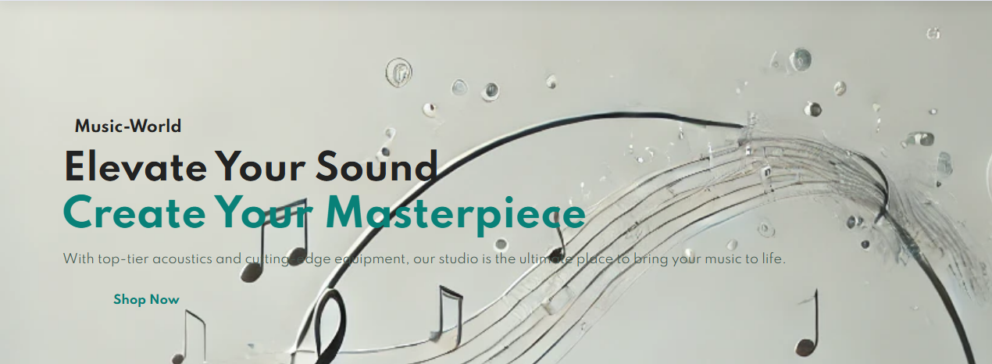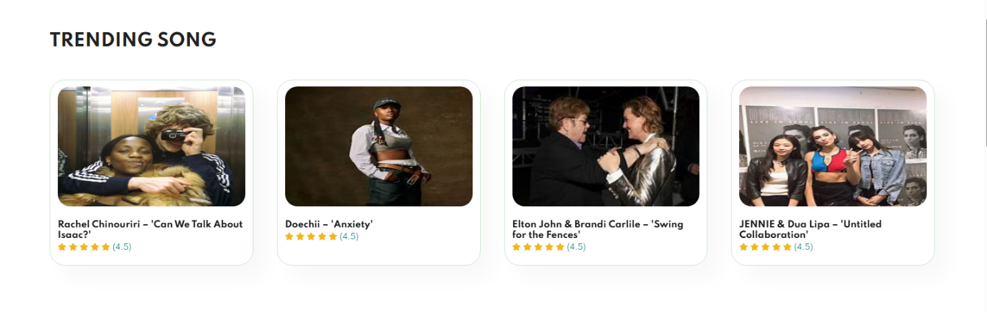 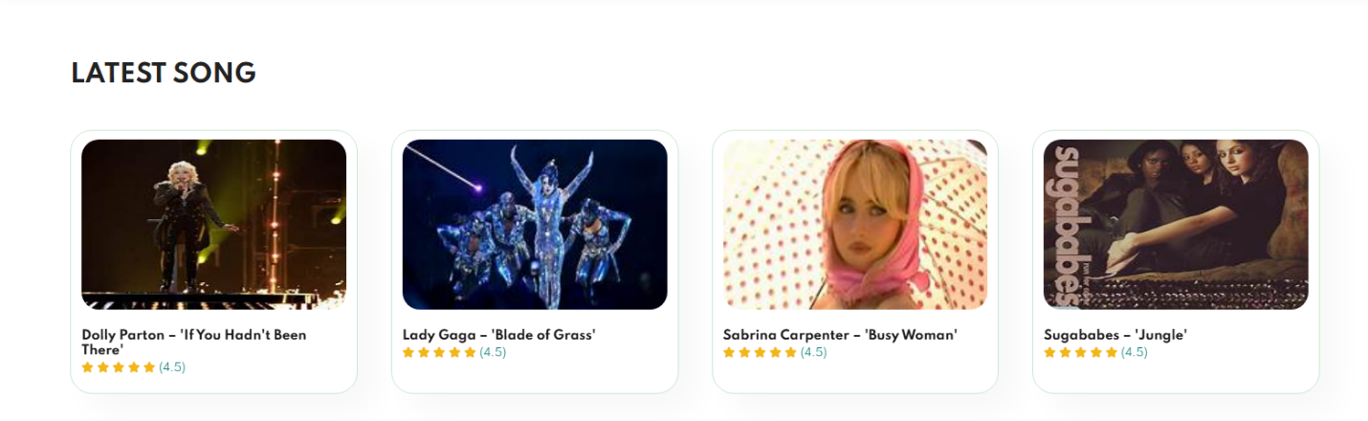

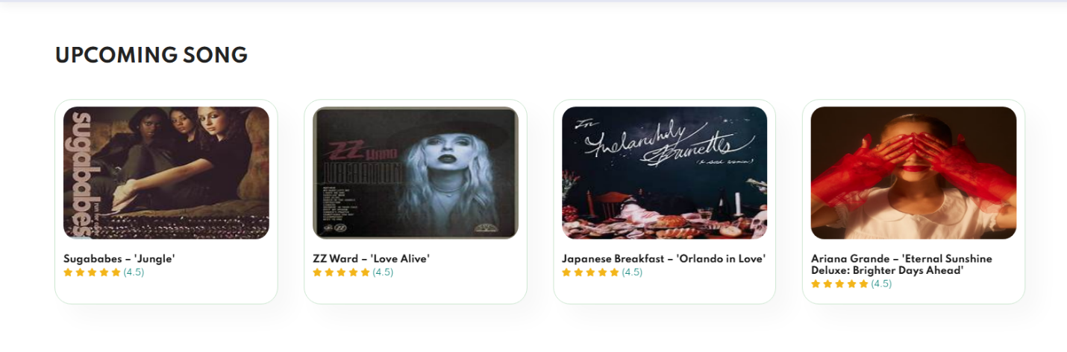

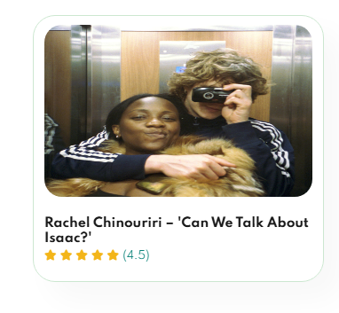 Click here to open a Card

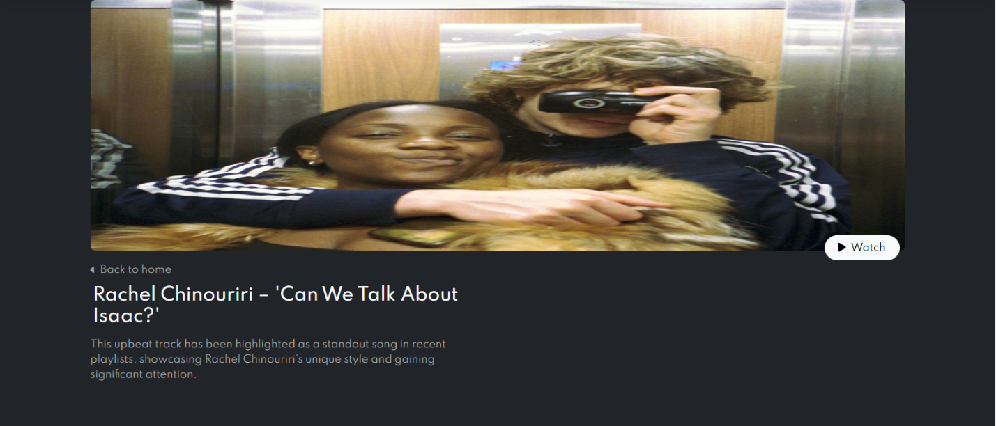

 Click here to Back to Home

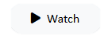 Click here to open a Modal

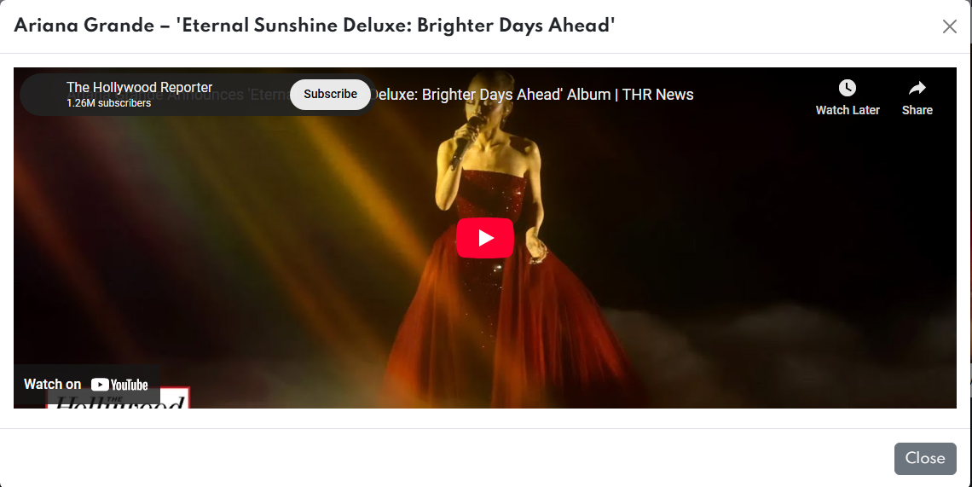



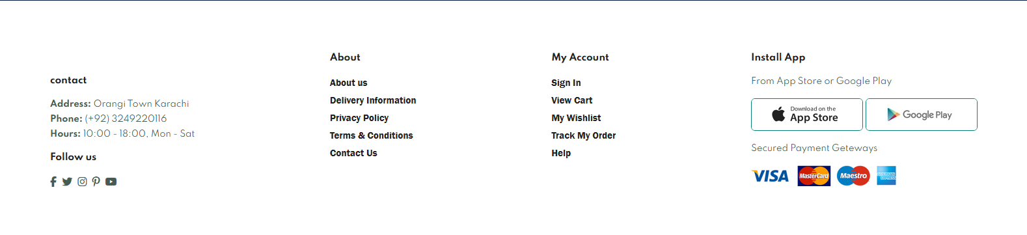

***SONG CATEGORY***

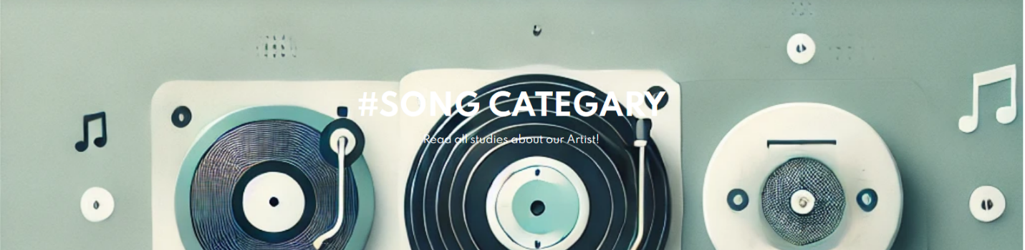

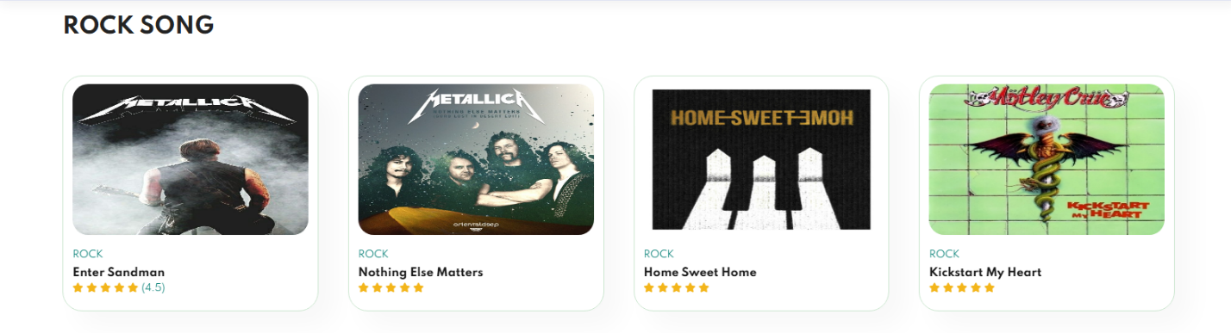

***Artist Gallery***



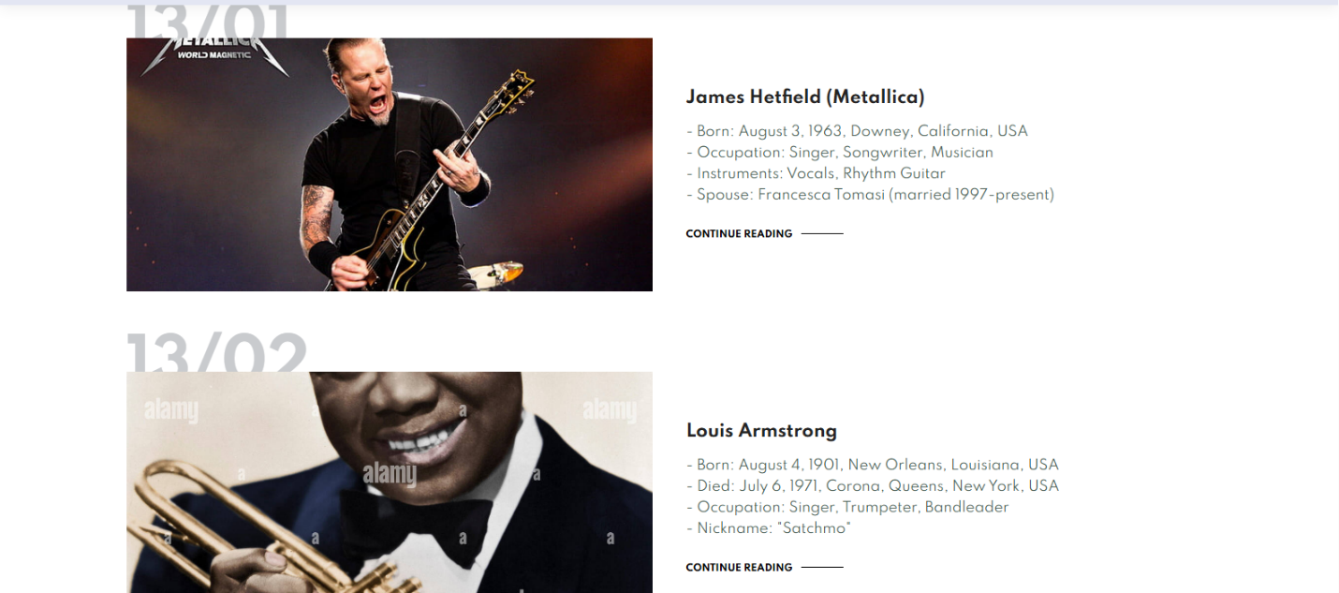

***ALBUM***



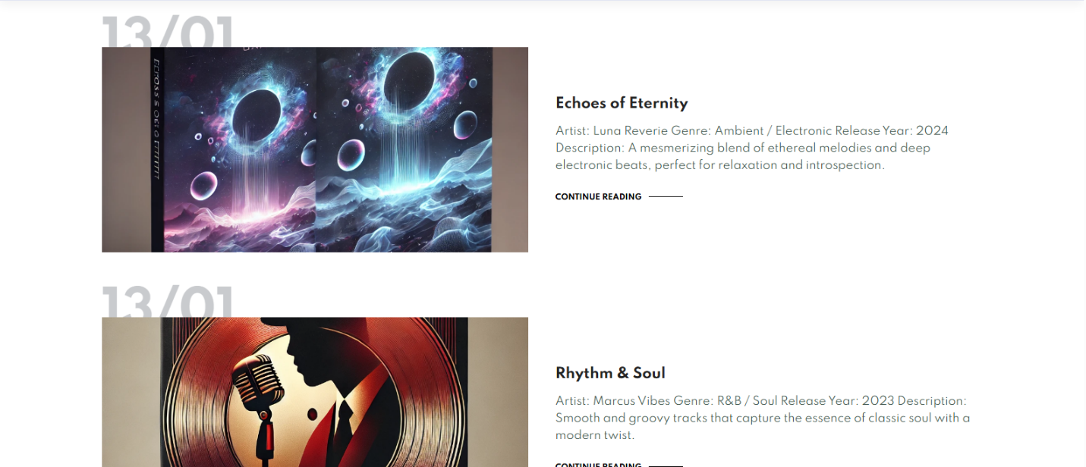

***CONTACT***



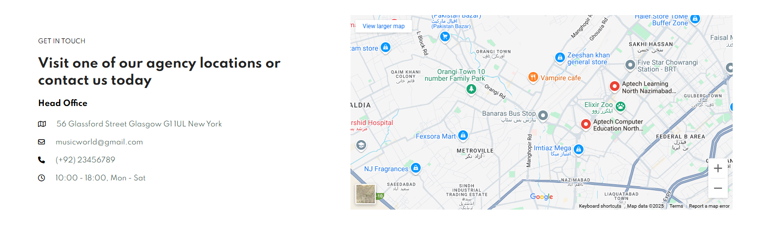

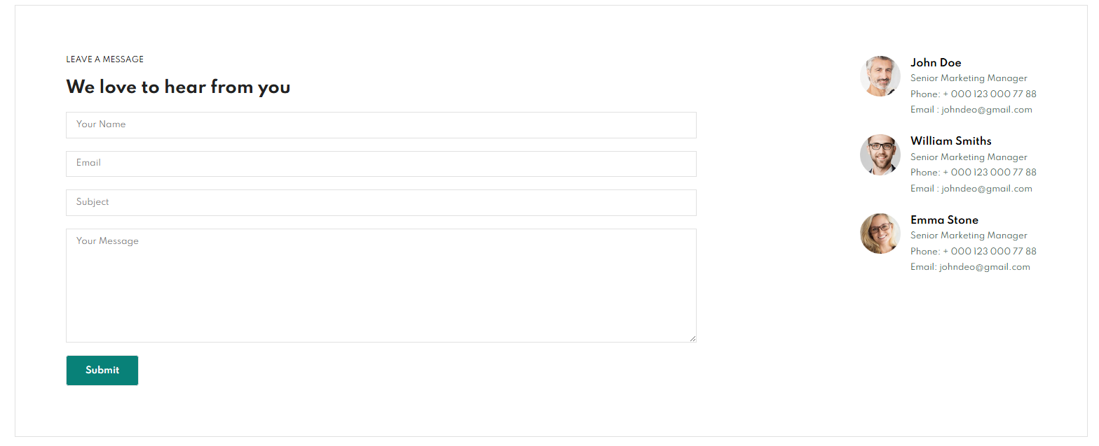

***Hardware/ Software Requirements***

***Hardware***

*- A minimum computer system that can access all the course tools is a Pentium 166 processor or better.*

*- At least 64 megabytes of RAM or more is required.*

***Software Requirements***

*(Use either one or a combination as per course/semester).*

*- Notepad, an HTML editor, or Coffee Cup.*

*- Angular, AngularJS, React, or Bootstrap.*

*- Dreamweaver or Figma.*

*- Web browsers: MS Internet Explorer, Chrome, Firefox, Netscape, or MS Edge.*

***Thank you so much for reading my User Guide Manual of the Website.***